**Network Properties in Spark GraphFrames(Answer)**

Wen-Han Hu(whu24)

**Degree Distribution**

1. All the random graphs are not scale free because they are not to follow the power law.

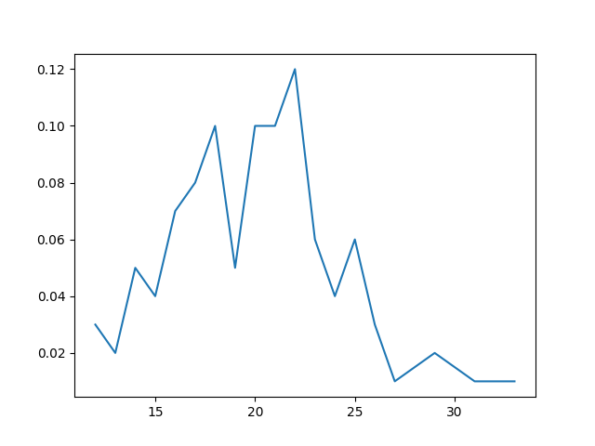fig. gnm1

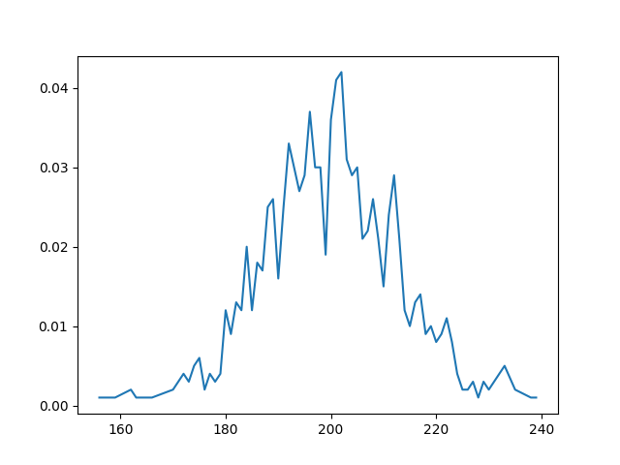fig. gnm2

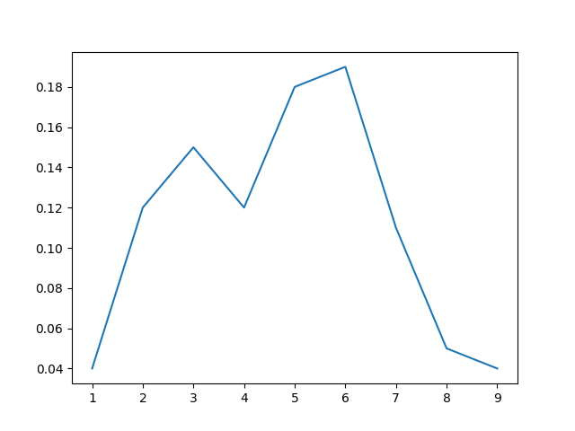fig. gnp1

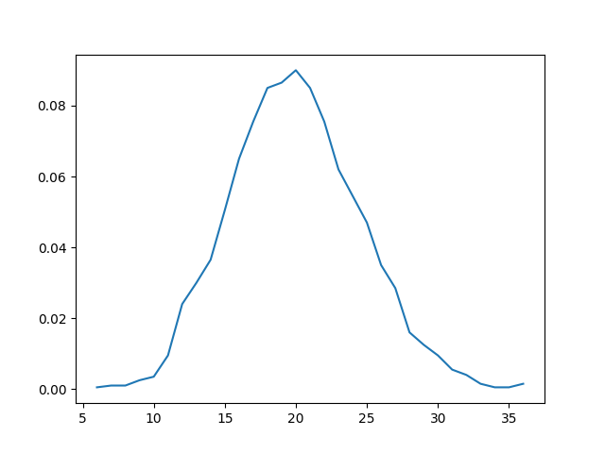fig. gnp2

1. All Standford graphs follow the power law. So, all of them are scale free.

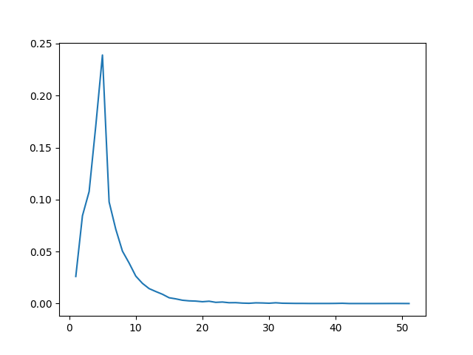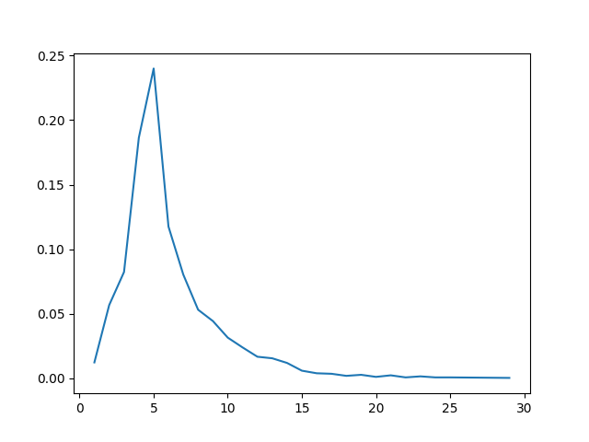

Fig. amazon.large Fig. amazon.small

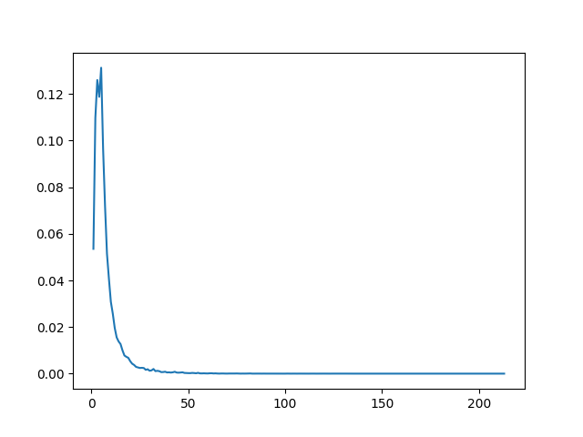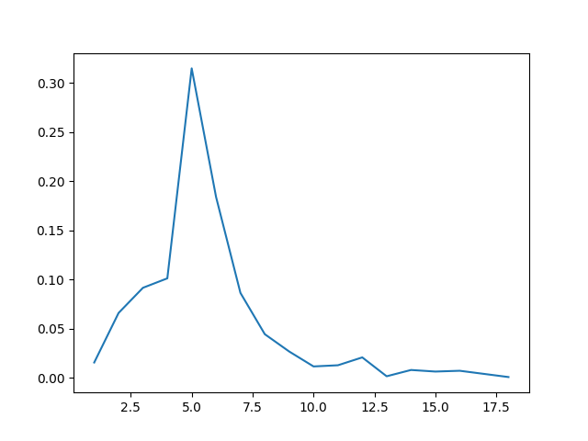

Fig. dblp.large Fig. dblp.small

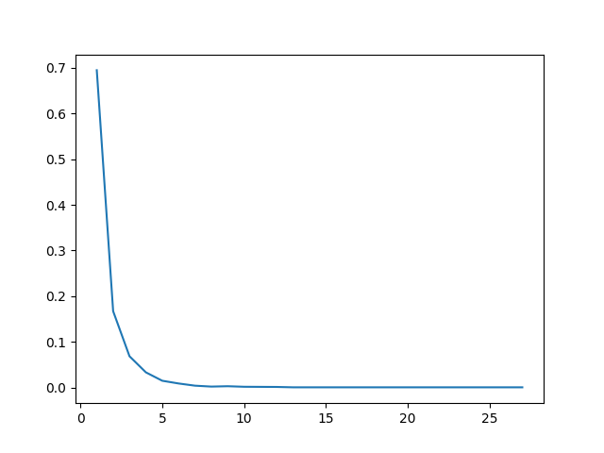

Fig. youtube.large Fig.youtube.small

**Centrality**

1. The rand of nodes as below:

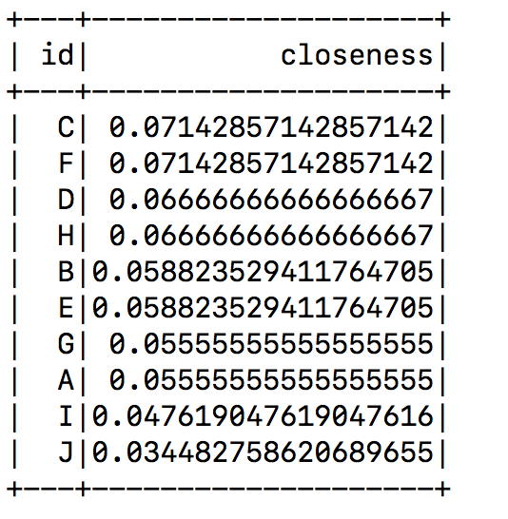

1. Node C and F will be the best options, since they have the highest rank of closeness centrality

**Articulation Points**

1. The members qualified for articulation points should have been targeted to best disrupt communication in the organization. The list as below:

